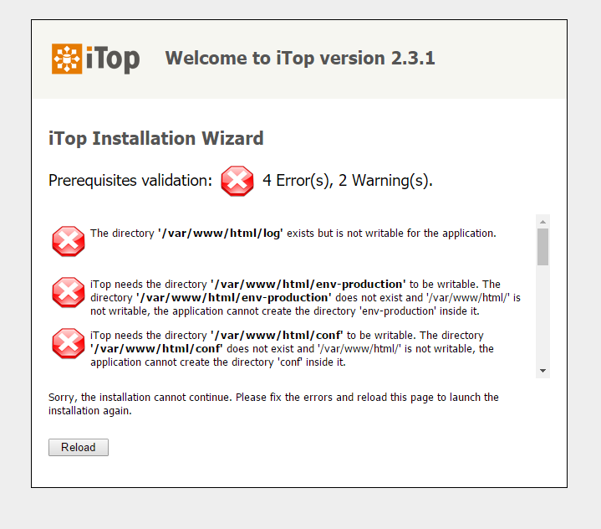

The directory **'/var/www/html/log'** exists but is not writable for the application.

iTop needs the directory **'/var/www/html/env-production'** to be writable. The directory **'/var/www/html/env-production'** does not exist and '/var/www/html/' is not writable, the application cannot create the directory 'env-production' inside it.

iTop needs the directory **'/var/www/html/conf'** to be writable. The directory**'/var/www/html/conf'** does not exist and '/var/www/html/' is not writable, the application cannot create the directory 'conf' inside it.

The directory **'/var/www/html/data'** exists but is not writable for the application.

Missing optional PHP extension: gd. PDF export of impact/dependency diagrams will be disabled

Missing optional PHP extension: mcrypt. Strong encryption will not be used.

The current PHP Version (5.4.16) is greater than the minimum version required to run iTop, which is (5.3.6)

Required PHP extension(s): dom, hash, iconv, json, mysqli, pcre, session, simplexml, soap, zip.

Optional PHP extension(s): ldap.

Loaded php.ini files: /etc/php.ini, /etc/php.d/curl.ini, /etc/php.d/dom.ini, /etc/php.d/fileinfo.ini, /etc/php.d/json.ini, /etc/php.d/ldap.ini, /etc/php.d/mysql.ini, /etc/php.d/mysqli.ini, /etc/php.d/pdo.ini, /etc/php.d/pdo_mysql.ini, /etc/php.d/pdo_sqlite.ini, /etc/php.d/phar.ini, /etc/php.d/soap.ini, /etc/php.d/sqlite3.ini, /etc/php.d/wddx.ini, /etc/php.d/xmlreader.ini, /etc/php.d/xmlwriter.ini, /etc/php.d/xsl.ini, /etc/php.d/zip.ini

The value for session.save_path (/var/lib/php/session) is writable for the web server.

解决方案：

赋予log文件的读写权限

#Chmod 777 log

创建文件夹**env-production 与 conf**

**#Mkdir env-production conf**

**变更文件夹权限**

**安装php-gd**

**#Yum install php-gd**

[**https://pkgs.org/centos-7/epel-x86_64/libmcrypt-2.5.8-13.el7.x86_64.rpm.html**](https://pkgs.org/centos-7/epel-x86_64/libmcrypt-2.5.8-13.el7.x86_64.rpm.html)

**在这个网站安装对应的包**

**Libmcrypt** mcrypt

需要重启httpd服务才能生效

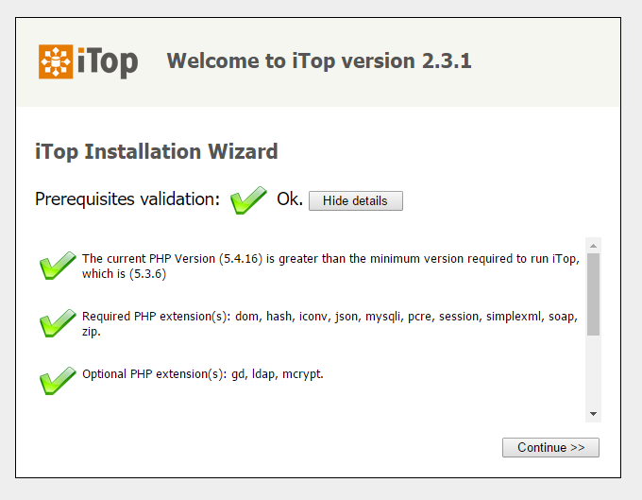

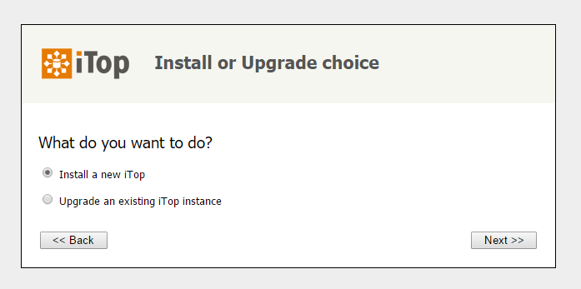

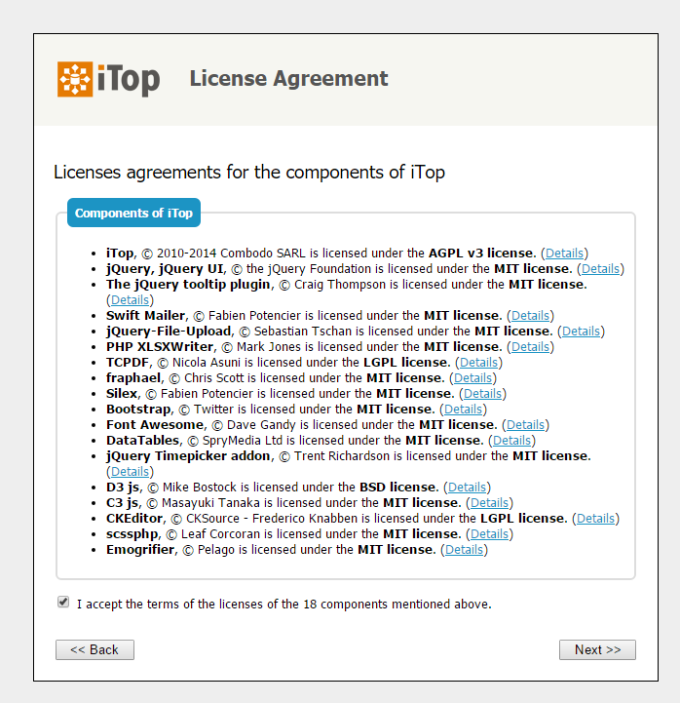

从最新版本的linux系统开始，默认的是 Mariadb而不是mysql！

使用系统自带的repos安装很简单：

yum install mariadb mariadb-server

systemctl start mariadb ==> 启动mariadb

systemctl enable mariadb ==> 开机自启动

mysql_secure_installation ==> 设置 root密码等相关

mysql -uroot -p123456 ==> 测试登录！

结束！

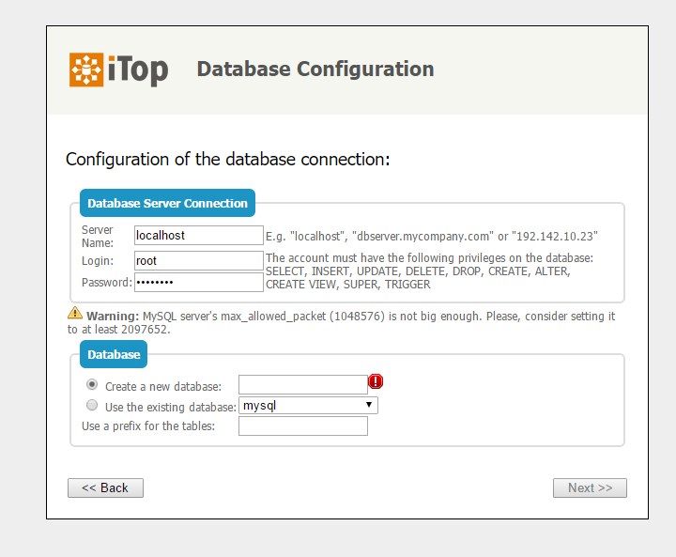

**Warning:** MySQL server's max_allowed_packet (1048576) is not big enough. Please, consider setting it to at least 2097652

解决方案：进入mysql，修改大小

#mysql –u root –p

输入密码

#set global max_allowed_packet = 2*1024*1024*10;

退出，刷新一下页面就好

